**CODE ARCHITECTURE FLOW: -**

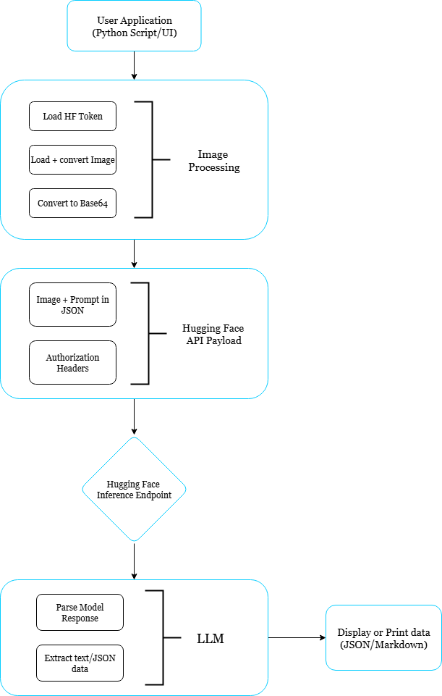

**OUTPUT FOR DIFFERENT MODELS: -**

* **Sample Input 1: -**

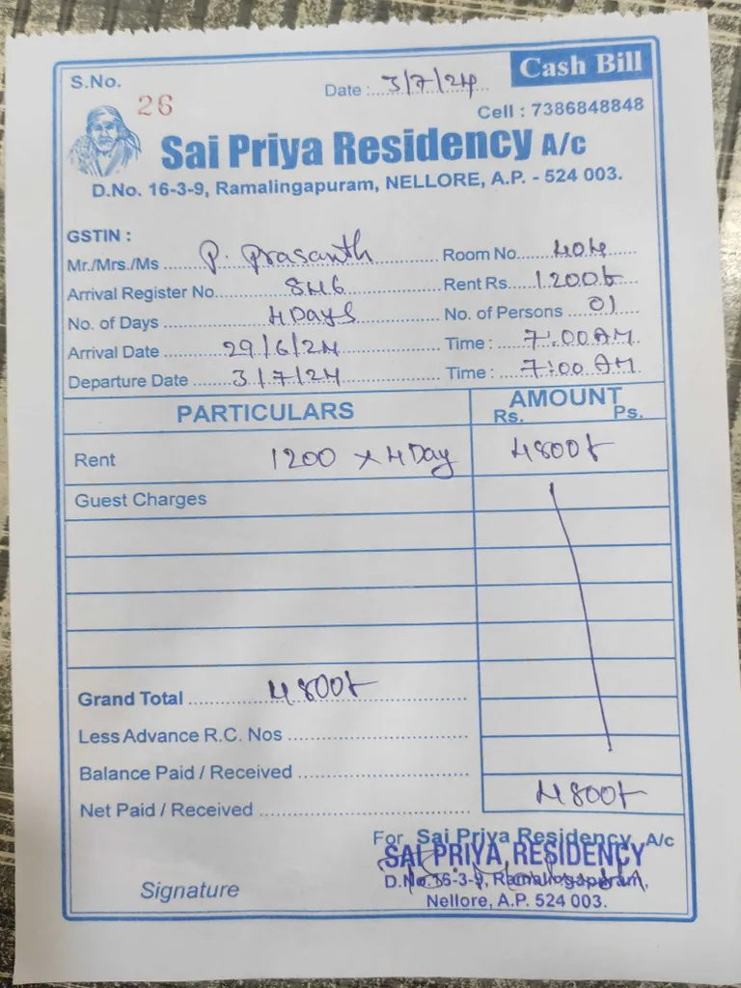

**OUTPUT: -**

* **Llama-3.2-11B-Vision-Instruct**

### **Bill Details**

|  |  |
| --- | --- |
| **Category** | **Details** |
| **Sai Priya Residency A/c** | Address: D.No. 16-3-9, Ramalingapuram, Nellore, A.P. - 524 003. |
| **GSTIN** | Mr./Mrs./Ms. P. Prasanth |
| **Arrival Register No.** | SME |
| **Arrival Date** | 29/6/24 |
| **Departure Date** | 3/7/24 |
| **Room No.** | 406 |
| **Rent Rs.** | 1200.0 |
| **No. of Days** | 4 Days |
| **No. of Persons** | 01 |
| **Arrival Time** | 7:00 AM |
| **Departure Time** | 7:00 AM |
| **Particulars** | **Amount (Rs.)** |
| **Rent** | 4800.0 |
| **Guest Charges** | 0.0 |
| **Grand Total** | 4800.0 |
| **Less Advance R.C. Nos** | 0.0 |
| **Balance Paid / Received** | 4800.0 |
| **Net Paid / Received** | 4800.0 |

### **Signature**

For Sai Priya Residency A/c Sai Priya Residency D.No.16-3-9, Ramalingapuram, Nellore, A.P. 524 003.

* **Qwen2.5-VL-72B-Instruct**

Here are the details from the bill image in markdown table format:

| S.No. | 26 |  
|-------|----|  
| Date | 31/7/24 |  
| Cell | 7386848848 |  
| **Sai Priya Residency A/c** | |  
| D.No. | 16-3-9, Ramalingapuram, NELLORE, A.P. - 524 003. |  
| GSTIN | |  
| Mr./Mrs./Ms | P. Prasanth |  
| Room No. | 404 |  
| Arrival Register No. | 816 |  
| Rent Rs. | 1200 |  
| No. of Days | 4 Days |  
| No. of Persons | 01 |  
| Arrival Date | 29/6/24 |  
| Time | 7:00 AM |  
| Departure Date | 31/7/24 |  
| Time | 7:00 AM |  
  
| PARTICULARS | AMOUNT |  
|-------------|--------|  
| Rent | 1200 x 4 Day |  
| Guest Charges | |  
| Grand Total | 4800 |  
| Less Advance R.C. Nos | |  
| Balance Paid / Received | |  
| Net Paid / Received | 4800 |

Note: The GSTIN field is empty in the image.

* **Ernie4.5-VL-424B-A47B**

Here's the extracted details from the bill image in markdown table format:

|  |  |
| --- | --- |
| **Detail** | **Value** |
| **S.No.** | 26 |
| **Date** | 3/7/24 |
| **Cell** | 7386848848 |
| **Residency Name** | Sai Priya Residency A/c |
| **Address** | D.No. 16-3-9, Ramalingapuram, NELLORE, A.P. - 524 003 |
| **GSTIN** | P. Prasanth |
| **Mr./Mrs./Ms** | P. Prasanth |
| **Room No.** | 104 |
| **Arrival Register No.** | 846 |
| **Rent Rs.** | 1200/- |
| **No. of Days** | 4 Days |
| **No. of Persons** | 01 |
| **Arrival Date** | 29/6/24 |
| **Time** | 7:00 A.M |
| **Departure Date** | 3/7/24 |
| **Time** | 7:00 A.M |
| **Rent** | 1200 x 4 Days = 4800/- |
| **Guest Charges** | - |
| **Grand Total** | 4800/- |
| **Less Advance R.C. Nos** | - |
| **Balance Paid / Received** | 4800/- |
| **Net Paid / Received** | 4800/- |
| **Signature** | For Sai Priya Residency A/c |

This table summarizes all the details from the bill image.

* **Gemma3-27B-IT-Fast**

Here are the details extracted from the bill image, presented in a Markdown table:

|  |  |
| --- | --- |
| **Detail** | **Value** |
| **S.No.** | 26 |
| **Date** | 19/12/2023 |
| **Cell** | 7336848848 |
| **Hotel Name** | Sai Priya Residency |
| **Address** | D.No. 16-3-9, Ramalingapuram, NELLORE, A.P. - 524 003 |
| **GSTIN** | P. Prasanth |
| **Mr./Mrs./Ms** | P. Prasanth |
| **Room No.** | 104 |
| **Arrival Register No.** | 346 |
| **Rent Rs.** | 1200/- (per day) |
| **No. of Days** | 4 Days |
| **No. of Persons** | 2 |
| **Arrival Date** | 29.1.6.24 |
| **Arrival Time** | 7:00 AM |
| **Departure Date** | 3.7.12.4 |
| **Departure Time** | 7:00 AM |
| **Rent** | 1200 x 4 Day = 4800 |
| **Guest Charges** | - |
| **Grand Total** | 4800/- |
| **Less Advance R.C. Nos.** | - |
| **Balance Paid / Received** | - |
| **Net Paid / Received** | 4800/- |
| **Signature Area** | - |

**Note:** The date formats (e.g., 29.1.6.24, 3.7.12.4) are as they appear in the image and might be interpreted differently. Also, some fields are empty or unclear in the image.

* **Sample Input 2: -**

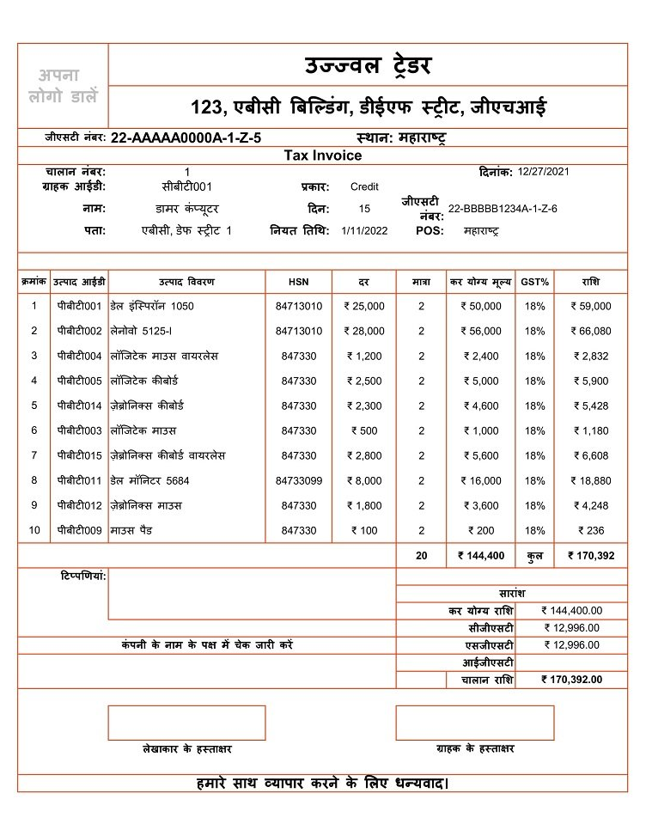

**OUTPUT: -**

* **Llama-3.2-11B-Vision-Instruct**

**Tax Invoice Details**

### **Invoice Header**

* **Invoice Number**: 22-AAA0000A-1-Z-5
* **Date**: 1/11/2022
* **GSTIN**: 22-BBB1234A-1-Z-6
* **Address**: 123, Ebenezer Building, DLF Street, Jeevachi

### **Tax Invoice Items**

|  |  |  |  |  |  |  |  |
| --- | --- | --- | --- | --- | --- | --- | --- |
| **Item Number** | **Description** | **HSN** | **Quantity** | **Rate** | **Amount** | **GST%** | **Amount** |
| 1 | Desktop Computer | 84713010 | 2 | ₹50,000 | ₹100,000 | 18% | ₹18,000 |
| 2 | Laptop | 5125-1 | 2 | ₹56,000 | ₹112,000 | 18% | ₹20,160 |
| 3 | Printer | 847330 | 1 | ₹1,200 | ₹1,200 | 18% | ₹216 |
| 4 | Laptop Keyboard | 847330 | 2 | ₹5,000 | ₹10,000 | 18% | ₹1,800 |
| 5 | Laptop Keyboard | 847330 | 2 | ₹4,600 | ₹9,200 | 18% | ₹1,656 |
| 6 | Laptop Mouse | 847330 | 2 | ₹1,000 | ₹2,000 | 18% | ₹360 |
| 7 | Laptop Keyboard | 847330 | 2 | ₹5,600 | ₹11,200 | 18% | ₹2,016 |
| 8 | Laptop Monitor | 5684 | 2 | ₹16,000 | ₹32,000 | 18% | ₹5,760 |
| 9 | Laptop Mouse | 847330 | 2 | ₹3,600 | ₹7,200 | 18% | ₹1,296 |
| 10 | Laptop Mouse Pad | 847330 | 2 | ₹200 | ₹400 | 18% | ₹72 |

### **Total Amount**

* **Total Amount**: ₹170,392
* **CGST**: ₹12,996
* **SGST**: ₹12,996
* **IGST**: ₹0

### **Payment Details**

* **Payment Method**: Cash
* **Payment Amount**: ₹170,392

### **Notes**

* **Note 1**: Please pay the amount within 7 days.
* **Note 2**: Please mention the invoice number while making the payment.

* **Qwen2.5-VL-72B-Instruct**

Here is the extracted information from the bill image displayed in a markdown table format:

| Sr. No. | Product Code | Product Description | HSN | Rate | Quantity | Taxable Amount | GST % | Amount |  
|---------|--------------|---------------------|-----|------|----------|----------------|-------|--------|  
| 1 | पीबीटी0001 | डेल इन्स्पिरॉन 1050 | 84713010 | ₹ 25,000 | 2 | ₹ 50,000 | 18% | ₹ 59,000 |  
| 2 | पीबीटी0002 | लेनोवो 5125-I | 84713010 | ₹ 28,000 | 2 | ₹ 56,000 | 18% | ₹ 66,080 |  
| 3 | पीबीटी0004 | लोजिटेक माउस वायरलेस | 847330 | ₹ 1,200 | 2 | ₹ 2,400 | 18% | ₹ 2,832 |  
| 4 | पीबीटी0005 | लोजिटेक कीबोर्ड | 847330 | ₹ 2,500 | 2 | ₹ 5,000 | 18% | ₹ 5,900 |  
| 5 | पीबीटी0014 | जेब्रोनिक्स कीबोर्ड | 847330 | ₹ 2,300 | 2 | ₹ 4,600 | 18% | ₹ 5,428 |  
| 6 | पीबीटी0003 | लोजिटेक माउस | 847330 | ₹ 500 | 2 | ₹ 1,000 | 18% | ₹ 1,180 |  
| 7 | पीबीटी0015 | जेब्रोनिक्स कीबोर्ड वायरलेस | 847330 | ₹ 2,800 | 2 | ₹ 5,600 | 18% | ₹ 6,608 |  
| 8 | पीबीटी0011 | डेल मॉनिटर 5684 | 84733099 | ₹ 8,000 | 2 | ₹ 16,000 | 18% | ₹ 18,880 |  
| 9 | पीबीटी0012 | जेब्रोनिक्स माउस | 847330 | ₹ 1,800 | 2 | ₹ 3,600 | 18% | ₹ 4,248 |  
| 10 | पीबीटी0009 | माउस पैड | 847330 | ₹ 100 | 2 | ₹ 200 | 18% | ₹ 236 |  
  
**Summary:**  
- Total Taxable Amount: ₹ 144,400.00  
- CGST: ₹ 12,996.00  
- SGST: ₹ 12,996.00  
- Grand Total: ₹ 170,392.00

### **Bill Details**

* **Company Name:** उज्जवल ट्रेडर
* **Address:** 123, एबीसी बिल्डिंग, डीईएफ स्ट्रीट, जीएचआर
* **GSTIN:** 22-AAAAA0000A-1-Z-5
* **State:** महाराष्ट्र

### **Customer Details**

* **Customer ID:** सोबीटी001
* **Name:** डामर कंप्यूटर
* **Address:** एबीसी, डेफ स्ट्रीट 1
* **GSTIN:** 22-BBBBB1234A-1-Z-6

### **Invoice Details**

* **Invoice Number:** 1
* **Date:** 12/27/2021
* **Due Date:** 1/11/2022
* **Place of Supply:** महाराष्ट्र
* **Payment Mode:** Credit ```

* **Ernie4.5-VL-424B-A47B**

Here's the extracted details from the bill in markdown table format:

|  |  |
| --- | --- |
| **Field** | **Details** |
| **Invoice Number** | 22-AAAAA0000A-1-Z-5 |
| **Date** | 12/27/2021 |
| **Customer ID** | सीबीट001 |
| **Type** | Credit |
| **Name** | डामर कंप्यूटर |
| **Days** | 15 |
| **Division** | 22-BBBBB1234A-1-Z-6 |
| **Place** | एबीसी बिल्डिंग, डीईएफ स्ट्रीट, जीएचआई |
| **Date of Issue** | 1/11/2022 |
| **POS** | महाराष्ट्र |

### **Item Details**

|  |  |  |  |  |  |  |  |  |
| --- | --- | --- | --- | --- | --- | --- | --- | --- |
| **Sr. No.** | **Item Code** | **Item Name** | **HSN** | **Quantity** | **Rate** | **Taxable Value** | **GST%** | **GST Amount** |
| 1 | सीबीट001 | जेनेरेटर 1050 | 84713010 | 2 | ₹25,000 | ₹50,000 | 18% | ₹59,000 |
| 2 | सीबीट002 | लैपटॉप 5125-I | 84713010 | 2 | ₹28,000 | ₹56,000 | 18% | ₹66,080 |
| 3 | सीबीट004 | सॉफ्टवेयर कार्यक्रम | 847330 | 2 | ₹1,200 | ₹2,400 | 18% | ₹2,832 |
| 4 | सीबीट005 | सॉफ्टवेयर कार्यक्रम | 847330 | 2 | ₹2,500 | ₹5,000 | 18% | ₹5,900 |
| 5 | सीबीट014 | जेनेरेटर की बोतल | 847330 | 2 | ₹2,300 | ₹4,600 | 18% | ₹5,428 |
| 6 | सीबीट003 | सॉफ्टवेयर माउस | 847330 | 2 | ₹500 | ₹1,000 | 18% | ₹1,180 |
| 7 | सीबीट015 | जेनेरेटर की बैटरी | 847330 | 2 | ₹2,800 | ₹5,600 | 18% | ₹6,608 |
| 8 | सीबीट011 | डेस मॉनिटर 5684 | 84733099 | 2 | ₹8,000 | ₹16,000 | 18% | ₹18,880 |
| 9 | सीबीट012 | जेनेरेटर माउस | 847330 | 2 | ₹1,800 | ₹3,600 | 18% | ₹4,248 |
| 10 | सीबीट009 | माउस पैड | 847330 | 2 | ₹100 | ₹200 | 18% | ₹236 |

### **Summary**

|  |  |  |  |
| --- | --- | --- | --- |
| **Total Quantity** | **Total Taxable Value** | **Total GST Amount** | **Grand Total** |
| 20 | ₹144,400 | ₹12,996 | ₹170,392 |

This table summarizes all the details from the provided bill image.

* **Gemma3-27B-IT-Fast**

Here's a markdown table representing the details extracted from the bill image:

## **Bill Details**

|  |  |
| --- | --- |
| **Field** | **Value** |
| **Logo** | अपना डालें |
| **Bill Type** | Tax Invoice |
| **Bill Number** | सीबी टी0001 |
| **Date** | 12/27/2021 |
| **Party Type** | Credit |
| **Name** | डामर कंप्यूटर |
| **Address** | एबीसी, डेफ़ स्ट्रीट 1 |
| **GSTIN** | 22-BBBB1234A-1Z-6 |
| **State** | महाराष्ट्र |
| **Place of Supply** | महाराष्ट्र |
| **Due Date** | 1/11/2022 |
| **POS** | महाराष्ट्र |
| **Sr. No.** | 1 |
| **Sr. No.** | 2 |
| **Sr. No.** | 3 |
| **Sr. No.** | 4 |
| **Sr. No.** | 5 |
| **Sr. No.** | 6 |
| **Sr. No.** | 7 |
| **Sr. No.** | 8 |
| **Sr. No.** | 9 |
| **Sr. No.** | 10 |
| **Total** |  |
| **Round Off** | ₹ -8 |
| **Grand Total** | ₹ 1,73,984 |

**Important Notes:**

* The Optical Character Recognition (OCR) may not be 100% accurate, especially with handwriting or poor image quality. There might be occasional errors.
* Some fields may be interpreted based on context where the image text is unclear.
* "अपना डालें" is left as is as it is assumed to be a placeholder for the logo.
* **Sample Input 3: -**

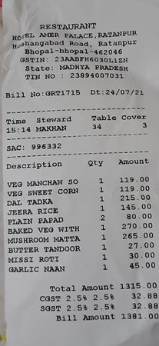

**OUTPUT: -**

* **Llama-3.2-11B-Vision-Instruct**

**Bill Details**

|  |  |
| --- | --- |
| **Field** | **Value** |
| **Bill No** | GRT1715 |
| **Date** | 24/07/21 |
| **Time** | 15:14 |
| **Steward** | MAKHAN |
| **Table Cover** | 3 |
| **SAC** | 996332 |
| **Description** | Qty |
|  | VEG MANCHAN SO |
|  | VEG SWEET CORN |
|  | DAL TADKA |
|  | JEERA RICE |
|  | PLAIN PAPAD |
|  | BAKED VEG WITH MUSHROOM MATTA |
|  | BUTTER TANDOOR |
|  | MISSI ROTI |
|  | GARLIC NAAN |
| **Total Amount** | 1315.00 |
| **CGST** | 2.5% 2.5% |
| **SGST** | 2.5% 2.5% |
| **Bill Amount** | 1381.00 |

* **Qwen2.5-VL-72B-Instruct**

Here are the details from the bill image in markdown table format:

| Field | Value |  
|------------------|------------------------|  
| Restaurant | Hotel Akbar Palace, Ratnampur |  
| Address | Bhopalganj Road, Ratnampur Bhopal-bhopal-462046 |  
| GSTIN | 23AABFH6030LLIZN |  
| State | MADHYA PRADESH |  
| TIN No | 23894007031 |  
| Bill No | GRT1715 |  
| Date | 24/07/21 |  
| Time | 15:34 |  
| Steward | MAXHAN |  
| Table | 34 |  
| Cover | 3 |  
| SAC | 996332 |  
| **Description** | **Qty** | **Amount** |  
| VEG MANCHAN SW | 1 | 119.00 |  
| VEG SWEET CORN | 1 | 119.00 |  
| DAL TADKA | 1 | 215.00 |  
| JEERA RICE | 1 | 145.00 |  
| PLAIN PAPAD | 2 | 80.00 |  
| BAKED VEG WITH | 1 | 270.00 |  
| MUSHROOM MATTA | 1 | 265.00 |  
| BUTTER TANDOORI | 1 | 27.00 |  
| MISSI ROTI | 1 | 30.00 |  
| GARLIC NAAN | 1 | 45.00 |  
| Total Amount | - | 1315.00 |  
| CGST 2.5% | - | 32.88 |  
| SGST 2.5% | - | 32.88 |  
| Bill Amount | - | 1381.00 |

* **Ernie4.5-VL-424B-A47B**

Here's the extracted details from the bill image in markdown table format:

|  |  |
| --- | --- |
| **Detail** | **Value** |
| **Restaurant** | HOTEL AMER PALACE, RATANPUR |
|  | Hoshangabad Road, Ratanpur |
|  | Bhopal-bhopal 462046 |
|  | GSTIN: 23AABFH6030L1ZN |
|  | State: MADHYA PRADESH |
|  | TIN: 23894007031 |
| **Bill Number** | GRT1715 |
| **Date** | 24/07/21 |
| **Time** | 15:14 |
| **Steward** | MAHARAN |
| **Table Cover** | 34 / 3 |
| **SAC** | 996332 |
| **Item Description** | **Quantity** |
| VEG MANCHURIAN | 1 |
| VEG SWEET CORN | 1 |
| DAL TADKA | 1 |
| JEERA RICE | 1 |
| PLAIN PAPAD | 2 |
| BAKED VEG WITH MUSHROOM MATTA | 1 |
| BUTTER TANDOOR | 1 |
| MISSI ROTI | 1 |
| GARLIC NAAN | 1 |
|  |  |
| **Total Amount** |  |
| **CGST 2.5%** |  |
| **SGST 2.5%** |  |
| **Bill Amount** |  |

This table summarizes all the details from the bill image.

* **Gemma3-27B-IT-Fast**

Here's the extracted information from the bill image, presented in a markdown table:

|  |  |
| --- | --- |
| **Information** | **Value** |
| **Restaurant Name** | HOTEL AMER PALACE |
| **Address** | Hoshangabad Road, Ratanpur, Bhopal-462046 |
| **GSTIN** | 23AABFH6030L1ZN |
| **State** | MADHYA PRADESH |
| **TIN No.** | 23894007031 |
| **Bill No.** | GRT1715 |
| **Date** | 24/07/21 |
| **Time** | 15:14 |
| **Steward** | 34 |
| **Table Cover** | 3 |
| **SAC** | 996332 |
| **Item** | **Qty** |
| Veg Manchaw So | 1 |
| Veg Sweet Corn | 1 |
| Dal Tadka | 1 |
| Jeera Rice | 1 |
| Plain Papad | 2 |
| Baked Veg With | 1 |
| Mushroom Matta | 1 |
| Butter Tandoor | 1 |
| Missi Roti | 1 |
| Garlic Naan | 1 |
| **Total Amount** |  |
| **CGST 2.5%** |  |
| **SGST 2.5%** |  |
| **Bill Amount** |  |

**Note:** There might be slight inaccuracies due to image quality and character recognition limitations.

* **Sample Input 4: -**

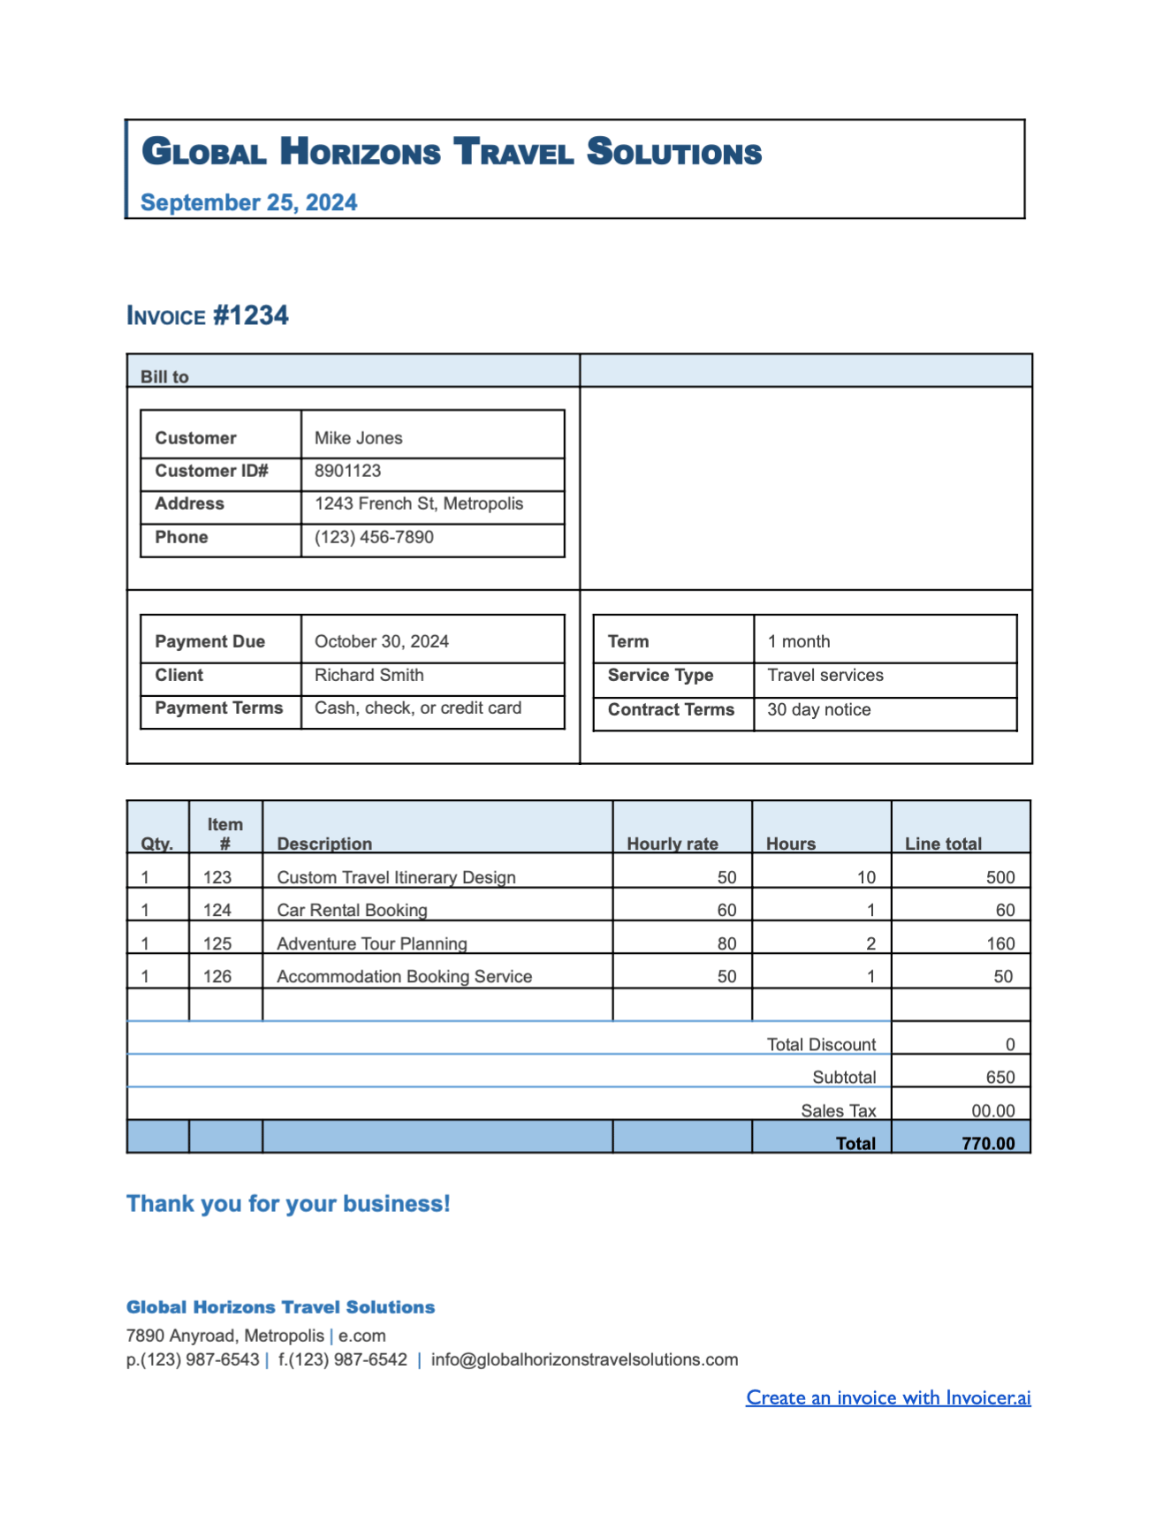

**OUTPUT: -**

* **Llama-3.2-11B-Vision-Instruct**

**Invoice Details**

|  |  |
| --- | --- |
| **Field** | **Value** |
| **Invoice Number** | 1234 |
| **Date** | September 25, 2024 |
| **Customer Name** | Mike Jones |
| **Customer ID** | 8901123 |
| **Address** | 1243 French St, Metropolis |
| **Phone** | (123) 456-7890 |
| **Payment Due Date** | October 30, 2024 |
| **Client** | Richard Smith |
| **Service Type** | Travel services |
| **Contract Terms** | 30 day notice |
| **Item #** | 123, 124, 125, 126 |
| **Description** | Custom Travel Itinerary Design, Car Rental Booking, Adventure Tour Planning, Accommodation Booking Service |
| **Hourly Rate** | 50, 60, 80, 50 |
| **Hours** | 10, 1, 2, 1 |
| **Line Total** | 500, 60, 160, 50 |
| **Total Discount** | 0 |
| **Subtotal** | 650 |
| **Sales Tax** | 00.00 |
| **Total** | 770.00 |

**Note:** The "Total Discount" field is listed as 0, indicating that there were no discounts applied to the invoice.

* **Qwen2.5-VL-72B-Instruct**

Here is the extracted information from the bill image in markdown table format:

| **Bill to** | **Details** |  
| --- | --- |  
| Customer | Mike Jones |  
| Customer ID# | 8901123 |  
| Address | 1243 French St, Metropolis |  
| Phone | (123) 456-7890 |  
| Payment Due | October 30, 2024 |  
| Client | Richard Smith |  
| Payment Terms | Cash, check, or credit card |  
| Term | 1 month |  
| Service Type | Travel services |  
| Contract Terms | 30 day notice |  
  
| **Qty.** | **Item #** | **Description** | **Hourly rate** | **Hours** | **Line total** |  
| --- | --- | --- | --- | --- | --- |  
| 1 | 123 | Custom Travel Itinerary Design | 50 | 10 | 500 |  
| 1 | 124 | Car Rental Booking | 60 | 1 | 60 |  
| 1 | 125 | Adventure Tour Planning | 80 | 2 | 160 |  
| 1 | 126 | Accommodation Booking Service | 50 | 1 | 50 |  
  
| **Total Discount** | **Subtotal** | **Sales Tax** | **Total** |  
| --- | --- | --- | --- |  
| 0 | 650 | 00.00 | 770.00 |

* **Ernie4.5-VL-424B-A47B**

**The details from the bill are extracted in the following markdown table format:**

**| Invoice Number | Invoice Date | Customer Name | Customer ID | Address | Phone | Payment Due Date | Term | Client Name | Service Type | Payment Terms | Item Number | Description | Hourly Rate | Hours | Line Total | Total Discount | Subtotal | Sales Tax | Total |**

**|----------------|--------------|---------------|-------------|---------|-------|-------------------|------|-------------|--------------|---------------|-------------|-------------|-------------|-------|-----------|---------------|----------|-----------|-------|**

**| #1234 | September 25, 2024 | Mike Jones | 8901123 | 1243 French St, Metropolis | (123) 456-7890 | October 30, 2024 | 1 month | Richard Smith | Travel services | Cash, check, or credit card | 123 | Custom Travel Itinerary Design | 50 | 10 | 500 | 0 | 650 | 0.00 | 770.00 |**

**| | | | | | | | | | | | 124 | Car Rental Booking | 60 | 1 | 60 | | | | |**

**| | | | | | | | | | | | 125 | Adventure Tour Planning | 80 | 2 | 160 | | | | |**

**| | | | | | | | | | | | 126 | Accommodation Booking Service | 50 | 1 | 50 | | | | |**

* **Gemma3-27B-IT-Fast**

Here are the details extracted from the bill image, presented in a markdown table format:

|  |  |
| --- | --- |
| **Detail** | **Value** |
| **Invoice Number** | #1234 |
| **Date** | September 25, 2024 |
| **Bill To** | Mike Jones |
| **Customer ID#** | 8901123 |
| **Address** | 1243 French St, Metropolis |
| **Phone** | (123) 456-7890 |
| **Payment Due** | October 30, 2024 |
| **Term** | 1 month |
| **Client** | Richard Smith |
| **Service Type** | Travel services |
| **Payment Terms** | 30 day notice |
| **Contract Terms** | Cash, check, or credit card |
| **Item #** | **Description** |
| 123 | Custom Travel Itinerary Design |
| 124 | Car Rental Booking |
| 125 | Adventure Tour Planning |
| 126 | Accommodation Booking Service |
|  | **Subtotal** |
|  | **Total Discount** |
|  | **Sales Tax** |
|  | **Total** |
| **Company Address** | 7890 Anyroad, Metropolis |
| **Company Email** | [info@globalhorizontravelsolutions.com](mailto:info@globalhorizontravelsolutions.com) |
| **Company Phone** | p.(123) 987-6543, f.(123) 987-6542 |